Experiment worksheet

7.1 The human body is divided into systems

Pages 116–117 and 203

Challenge 7.1: Brown paper body brainstorm

What you need

• Large pieces of butcher’s paper

• Several different-coloured felt-tipped pens

What to do

1 Working with a partner, spend 5 minutes brainstorming all the internal parts of the body you can think of. Write them down in your notebook as you brainstorm.

2 Unravel a couple of metres of butcher’s paper along the floor.

3 Have one student lie down on the paper. Trace around them.

4 Spend a minute discussing the best way to illustrate the body shape with all the body parts from your brainstorming list. What is the best way to make use of the different-coloured pens?

5 Then, using the list you brainstormed and any other body parts you think of as you work, make a drawing of the inside of a human body.

6 Try to make connections between body parts where you can. For example, you may want to connect the stomach to the intestines.

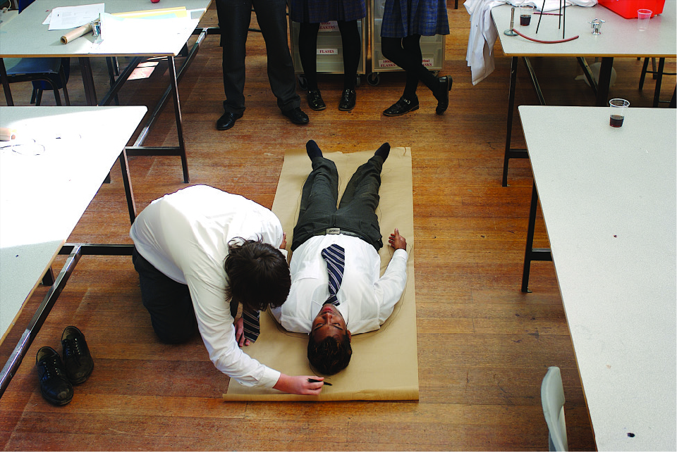

Figure 1 Draw a model of the survival system of your body.

Experiment worksheet

7.2 The digestive system is made up of organs

Pages 118–119 and 204

Challenge 7.2A: Digesting protein

Aim

To investigate the function of pepsin, an enzyme found in the stomach, and to establish the conditions under which pepsin functions best. Egg white is being used as the source of protein in this experiment.

Materials

• 4 test tubes and test tube rack

• Permanent marker

• Hard-boiled egg white

• 10 mL measuring cylinder

• 1% pepsin solution

• Water

• Dilute hydrochloric acid (1 M HCl)

• Dilute sodium hydroxide solution (0.1 M NaOH)

• 1 mL pipette

• Incubator (37°C)

Safety

Bring the materials to the test tubes, rather than risking them being dropped when carrying them around the room.

**CAUTION!** SOME STUDENTS MAY HAVE EGG ALLERGIES

**CAUTION!** DANGEROUS CHEMICALS ARE INVOLVED¬ POUR CAREFULLY, CLEAN UP ALL SPILLS IMMEDIATELY AND RINSE YOUR HANDS IF YOU COME INTO CONTACT WITH ANY CHEMICALS.

Method

1 Label four test tubes A, B, C and D with the permanent marker.

2 Collect some hard-boiled egg white. Cut four cubes of approximately 1 cm3 ensuring that the cubes are the same.

3 Put a cube of egg white in each tube.

4 Add 10 mL pepsin to tubes A, C and D.

5 Add 10 mL water to tube B.

6 Add ten drops of HCl to tubes A and B.

7 Add ten drops of 0.1 M NaOH to tube D.

8 Add ten drops of water to tube C.

9 Bind the four tubes with a rubber band and label the bunch with your initials.

10 Incubate for at least 24 hours at 37°C.

Results

Record the ingredients for each tube with a tick or cross in Table 1. Provide very brief statements to describe your observations of the results.

Table 1

|  |  |  |  |  |  |  |
| --- | --- | --- | --- | --- | --- | --- |
| Tube | Egg whitE | Pepsin solution | HCI | **NaOH** | Water | Results |
| A |  |  |  |  |  |  |
| B |  |  |  |  |  |  |
| C |  |  |  |  |  |  |
| D |  |  |  |  |  |  |

Discussion

1 This experiment is a ‘controlled’ experiment. What do you understand this term to mean?

2 How can combining the class’s data improve the accuracy of the interpretations?

3 Construct a sentence to explain how the comparison of tubes relates to the human stomach for A and B, A and C, and A and D.

4 In which test tube(s) has the protein been almost completely digested? How do you know?

5 Has the pepsin digested the protein? If so, how can you be sure?

6 What are enzymes?

7 Does HCl digest the protein by itself? How do you know?

8 Complete the following word equations to show what has happened in this experiment.

Tube A: protein +______________ +______________🡪amino acids

Tube B: water +______________+______________🡪______________

Tube C: pepsin +______________ +______________🡪______________

Tube D: pepsin +______________ +______________🡪______________

9 Why does the body digest protein? What would happen to the protein after it has been digested?

10 Predict what would happen if this experiment was repeated with carbohydrates instead of protein, leaving the rest of the experiment exactly the same.

Conclusion

What do you know about the function of pepsin and the conditions under which pepsin functions best?

Experiment worksheet

7.2 The digestive system is made up of organs

Pages 118–119 and 205

Experiment 7.2B: What if an enzyme was boiled?

The gelatine in jelly is a protein that can be broken up by an enzyme found in fresh pineapple or kiwi fruit. For this reason many packets of jelly come with a warning not to add fresh fruit to the jelly.

Aim

To determine what conditions are needed for an enzyme to digest protein.

Materials

• Jelly crystals

• Boiling water to make up jelly

• Large beaker to make up jelly

• 3 × 100 mL beakers

• Fresh pineapple

• Boiled pineapple

• Tinned pineapple

Method

1 Make up the jelly according to the instructions on the packet.

2 Pour 50 mL of liquid jelly into two beakers.

3 Add a few pieces of the fresh pineapple to one of the beakers.

4 Allow to cool overnight in the fridge.

5 Record your observations in a table.

Inquiry

Choose one of the questions below to investigate.

• What if the pineapple was boiled before being added to the jelly?

• What if tinned pineapple was added to the jelly?

Answer the following questions in relation to your inquiry.

• Write a hypothesis for your question.

• What (independent) variable will you change from the first method?

• What (dependent) variable will you measure/observe?

• Name three variables you will keep the same/control.

Results

Draw a table to record your observations in the space provided.

|  |
| --- |
|  |

Discussion

1 Describe the difference between the jelly with the fresh pineapple and the jelly with no pineapple.

2 Use the term ‘chemical digestion’ to explain your observations.

3 Was your hypothesis supported in your inquiry? Explain your answer.

4 Suggest an alternative reason for the results you obtained in your inquiry.

Conclusion

Explain why you should not add fresh pineapple to jelly.

Experiment worksheet

7.5 The respiratory system exchanges gases

Pages 124–125 and 206

Challenge 7.5A: Measure your lung capacity

What you need

• A large 5 litre container

• Access to a large sink or tub

• 1 metre of tubing

What to do

1 Place 10 cm of water in the bottom of a sink.

2 Fill the container with water.

3 Tip the container upside down in the sink so that the opening is submerged. This will prevent the water leaving the container.

4 Place one end of the tubing under the opening of the container.

5 Take a deep breath and blow as much as you can into the tubing. As you blow air into the container, the water should be pushed out the bottom.

6 Measure how much air you are able to blow out of your lungs into the container.

Discussion

1 Can you repeat the results by performing your experiment two more times?

2 Is there a chance your results could have been affected by something else? For example, do you have a lung infection?

3 Compare your results to others in the class. Can you notice any relationship between height of the person and their lung capacity?

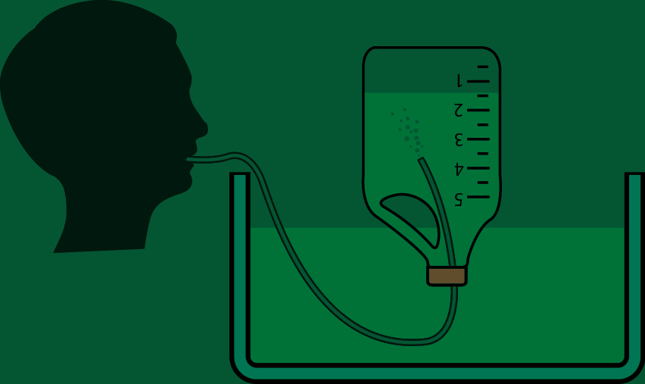

Figure 1 Measure the capacity of your lungs

Experiment worksheet

7.5 The respiratory system exchanges gases

Pages 124–125 and 206

Challenge 7.5B: Fish dissection

What you need

• A fish, complete with internal organs, from a fishmonger or market

• Dissection tools

**SAFETY** REFER TO CHAPTER 1 FOR DISSECTION SKILLS AND SAFETY GUIDELINES.

PART A

What to do

Use your dissection skills to open the abdomen and head of the fish and record your observations of the internal organs using labelled diagrams.

Discussion

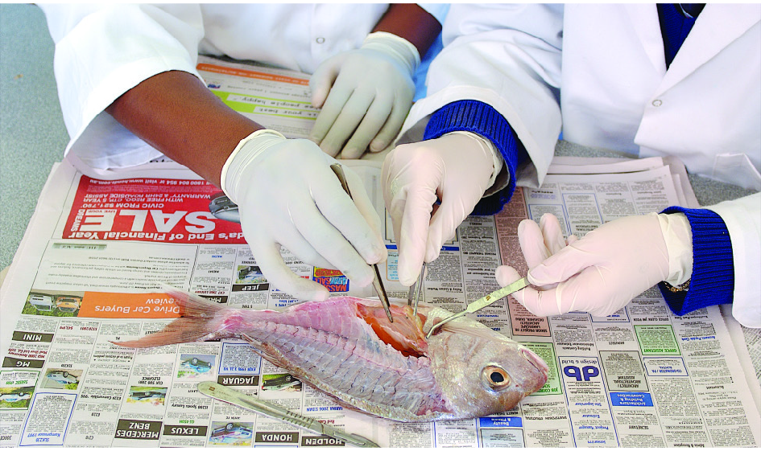

1 What do you notice about the arrangement of the organs?

2 Are the systems clearly separated or are they intertwined?

3 Are certain organs a darker red colour than others?

4 What might this tell you about their blood supply?

5 What might this tell you about their importance?

PART B

Figure 1 Identify the key organs in the

dissected fish.

What to do

Identify and remove the gills of the fish. Reflect on the significant features of our lungs that make them such effective gas exchange organs.

Discussion

1 Do fish gills have similar features to lungs?

2 Do they have different forms to achieve the same function?

Experiment worksheet

7.7 The circulatory system carries substances around the body

Pages 128–129 and 207

Experiment 7.7: Heart dissection

Aim

To explore the structure and function of a heart.

Materials

• Sheep, cow, ox or pig heart

• Scalpel

• Newspaper

• Dissecting probe and forceps

**SAFETY** REFER TO CHAPTER 1 FOR DISSECTION SKILLS AND SAFETY GUIDELINES.

Method

1 Examine the outside of the heart and identify the left and right sides. Your fingers will work better than a probe for that.

2 Use your fingers to feel the right side of the heart. Compare the thickness of the right and left sides. Feel the muscle in the centre of the heart.

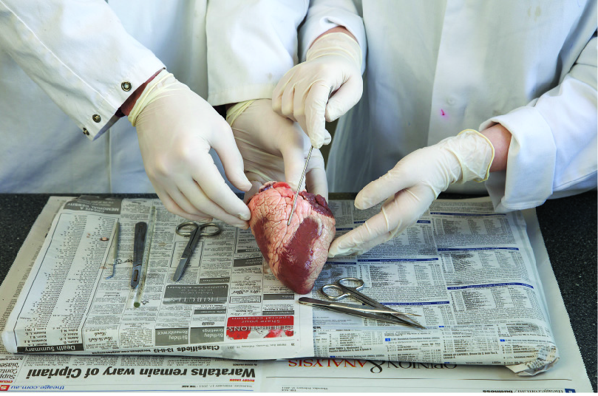

Figure 1 Identify the right and left sides of the heart.

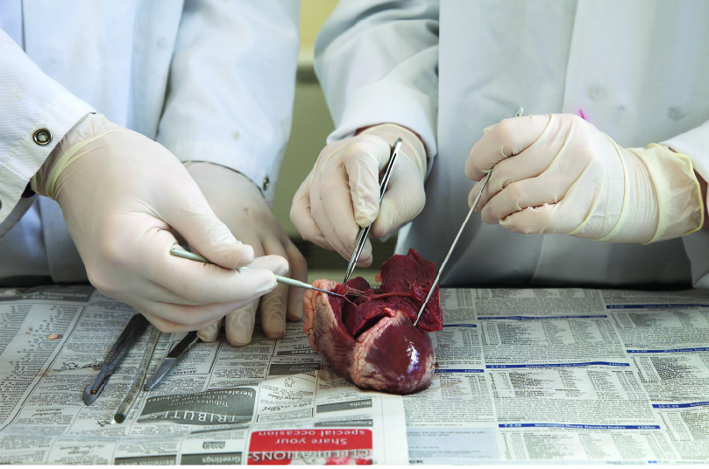

Figure 2 Compare the thicknesses of the right and left ventricles.

3 Using a scalpel, cut open the right atrium and right ventricle. Pull back the wall and look inside to see the atrium and the ventricle. The ventricle is the chamber closest to the pointed end of the heart. The white tendons hold the valves in place.

4 Push a dissecting probe or your finger out through the artery leading from the right ventricle.

5 Cut open the left side of the heart. Locate the atrium, ventricle and tendons holding the valves.

6 Push a dissecting probe or your finger out through the artery leading from the left ventricle.

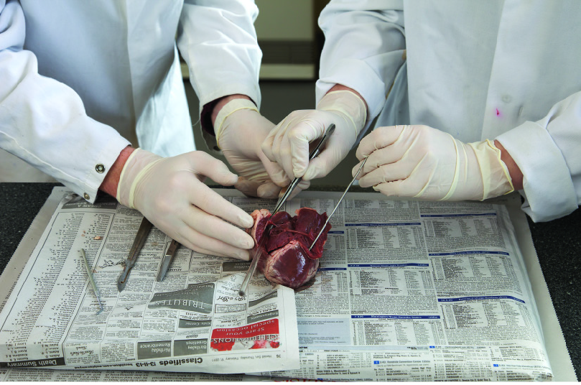

Figure 3 Use the dissecting probe to identify the arteries.

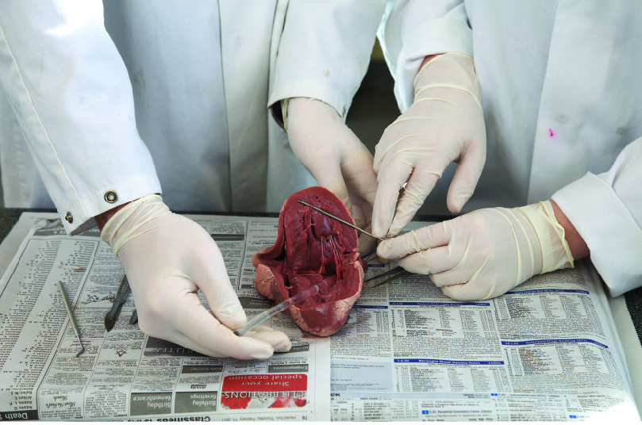

Figure 4 Identify the artery leaving the left ventricle

Results

Include labelled diagrams and observations here.

|  |
| --- |
|  |

Discussion

1 What is the artery from Method step 4 called?

2 What is the artery from Method step 6 called?

3 How does the thickness of this artery wall compare with the thickness of a vein wall?

4 How does the thickness of ventricle walls compare with that of atrial walls?

5 How can you explain the difference between the left and right ventricle walls?

Conclusion

What do you know about the structure and function of the heart?

Experiment worksheet

7.8 Things sometimes go wrong in the circulatory system

Pages 130–131 and 208

Challenge 7.8: Modelling blood flow

What you need

• Scissors

• Plastic cups

• 1 thin straw

• Play dough

• 1 thick straw

• Food colouring

• Water

• Large tray

• Timer

What to do

1 Use the scissors to poke a straw-sized hole through the side of the cup.

2 Place the thin straw through the hole of the cup making sure the straw is not being squeezed.

3 Use play dough to seal around the hole so that there are no leaks. Water should only be able to escape through the straw.

4 Cut the straw so that it is 5 cm in length.

5 Repeat this with another cup for the thick straw making sure the straw is placed in approximately the same height from the cup’s base.

6 Place the cups in the tray and fill both cups with equal amounts of coloured water.

7 Time how long each cup takes to become empty.

Discussion

1 What effect did narrowing the straws have in the effectiveness of water flow?

2 What complication of the circulatory system does this model reflect?

3 Treatment for this complication involves inserting a small balloon into the blood vessel and allowing it to stretch the vessel so that it becomes wider. How will this help the patient?

Experiment worksheet

7.9 The excretory system removes waste

Pages 132–133 and 208

Experiment 7.9: Kidney dissection

Aim

To investigate the structure of a mammalian kidney and explore the various functions of the different parts.

Materials

• Sheep’s kidney

• Dissecting kit

• Dissecting board

**CAUTION!** REFER TO CHAPTER1 FOR DISSECTION SKILLS ANDSAFETY GUIDELINES.

Method

1 Place the whole kidney on the board and identify as many parts as possible.

2 Draw a labelled diagram.

3 Cut the kidney in half longitudinally (lengthways).

4 Draw a labelled diagram.

Results

Include your labelled diagrams here.

|  |
| --- |
|  |

Discussion

1 What did you notice about the colour of the kidney on the outside compared with the inside?

2 The colour of the kidney gives an indication of the amount of waste products it contains. How does this support your observations?

3 Could you actually see any nephrons? What does this tell you about their size and the size of the substances they filter?

4 The medulla, the middle section of the kidney, has a stripy appearance. This is due to the collecting ducts heading in the same direction. Where are they heading?

Conclusion

What do you know about the form and function of a mammalian kidney?

Experiment worksheet

7.10 Plants have tissues and organs

Pages 134–135 and 209

Challenge 7.10A: Locating the stomata of a leaf

What you need

• Clear fingernail polish

• Fresh plant leaf

• Clear sticky tape

• Glass slide

• Microscope

What to do

1 Paint a thick patch of clear nail polish in the underside of the leaf and allow to dry.

2 Place a piece of the clear sticky tape over the dried nail polish.

3 Gently peel the sticky tape off the leaf, removing the nail polish patch from the leaf’s surface.

4 Tape the peeled section of leaf onto the glass slide.

5 Examine the slide under the microscope and locate a stoma (singular of stomata).

6 Draw a labelled diagram of the stoma.

|  |
| --- |
|  |

Discussion

1 What function do stomata have in a plant?

2 Was the stoma you located open or closed?

3 Refer to the time of day and the location of the plant to explain why the stoma on your plant was open or closed.

Experiment worksheet

7.10 Plants have tissues and organs

Pages 134–135 and 209

Challenge 7.10B: Locating the xylem and phloem in a stem

What you need

• 500 mL beaker

• Water

• Blue or red food colouring

• Fresh stick of celery

• Scalpel and cutting board

• Permanent marker

• Magnifying glass

What to do

1 Add 200 mL of water to the beaker.

2 Add 15 drops of food colouring to the water.

3 Cut the bottom 10 cm off the celery.

4 Place the top half of the celery in the beaker of coloured water.

5 Mark the water level with a permanent marker. Leave for 2–3 days.

6 Remove the celery from the water and use the scalpel to cut a horizontal transverse section of the celery stalk.

7 Locate the pathway by which the coloured water moved through the celery. Draw a labelled diagram of the celery cross-section.

|  |
| --- |
|  |

Discussion

1 What did you notice about the amount of water in the beaker after 2–3 days?

2 Use the term 'transpiration' to explain your answer to the previous question.

3 What is the name of the pathway that moved the coloured water through the celery?

4 How is this similar to the circulatory system in humans? How is it different?

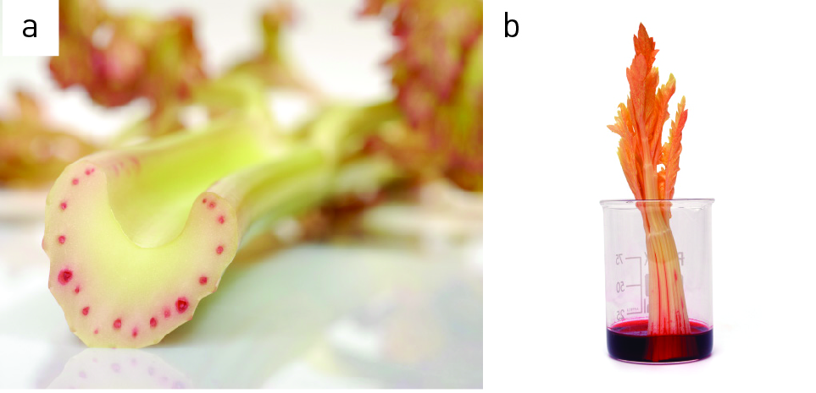

Figure 1 (a) The dye marks the path the water takes from the roots. (b) As water evaporates from the leaves, the dye water replaces it.

Experiment worksheet

7.10 Plants have tissues and organs

Pages 134–135 and 210

Challenge 7.10C: Modelling root cells

What you need

• 15 cm dialysis tubing

• Distilled water

• 5 mL of 2% starch solution

• Scales

• 200 mL beaker

What to do

1 Soften the dialysis tubing by running distilled water over the outside of it.

2 Tie a knot in one end of the tubing.

3 Add 5 mL of starch solution to the tubing.

4 Seal the open end by tying a knot.

5 Wash the outside of the tubing with distilled water.

6 Pat the outside of the tubing dry and determine its weight using the scales.

7 Place the tubing in the beaker. Add 100 mL distilled water.

8 Leave overnight.

9 Remove the dialysis tubing from the water and carefully pat dry.

10 Determine the weight of the dialysis tubing.

Discussion

1 What was the difference in weight of the dialysis tube with starch before and after soaking in water?

2 What caused the change in the weight of the tubing?

3 What is osmosis?

4 Use the term ‘osmosis’ to explain how the dialysis tubing is similar to the cells in a root.

Experiment worksheet

7.10 Plants have tissues and organs

Pages 134–135 and 210

7.10 Experiment: Factors that affect transpiration

Aim

To determine the factors that affect the transpiration of water from plants.

Materials

• 200 mL measuring cylinders

• Water

• Fresh celery stalks

Method

1 Add 100 mL of water to one of the measuring cylinders.

2 Cut the bottom 10 cm off a celery stalk and trim so that the end of it fits into the measuring cylinder.

3 Place the top half of the celery in the measuring cylinder.

4 Mark the water level with a permanent marker. Leave for 2–3 days at room temperature.

5 Measure how much water has been lost by the celery stick.

Inquiry: Choose one of the questions below to investigate

• What if the celery was placed in sunshine?

• What if the celery was placed in wind? (A fan may be used.)

• What if the celery was placed in a humid environment? (A large clear plastic bag may be placed over the celery.)

Answer the following questions in relation to your inquiry.

Write a hypothesis for your question.

What (independent) variable will you change from the first method?

What (dependent) variable will you measure/observe?

Name three variables you will keep the same/control.

Results

Record your observations and measurements in a table using the space provided.

|  |
| --- |
|  |

Discussion

1 What is transpiration?

2 What factors would you expect to affect transpiration?

3 Did your results support your hypothesis? Use evidence from your results to support your answer.

4 How could you use your results to support the plants in your garden?

Conclusion

What do you know about the factors that affect transpiration?